Connect to the DFM (<https://dfmc-cis-alrm-e01.int.thomsonreuters.com>) and login

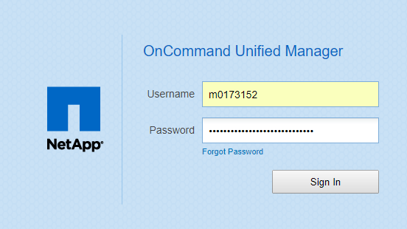

Click Add Cluster

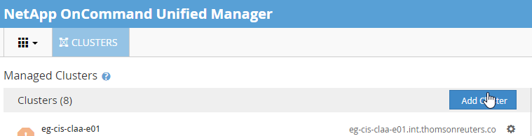

Fill in details

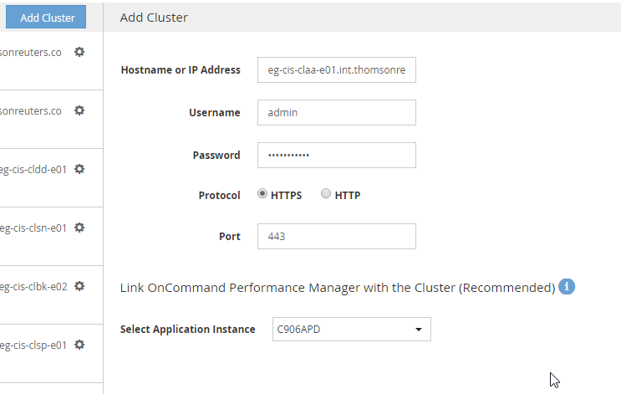

Click save

